**ART GALLERY MANAGEMENT**

**OBJECTIVE:**

To create an Art Gallery Management System that keeps record of the artists, their paintings, art gallery details, exhibition details and showcase pictures of paintings to the customers

**ABSTRACT:**

Many art gallery exhibitions are held for exhibiting paintings by various artists in order to showcase their talent. As a part of this various customers will be visiting the Art gallery to buy paintings and there are few customers who have keen interest about the paintings will observe each and every art in the art gallery.

A Customer who visits the Art Gallery will be asked for Customer id. The Customer should enter his Name, Email id, Password, Customer ID given to him, Phone Number and Address it has to get reflected on the customer’s table. After entering into the gallery, each art consists of Art id, Art name, Type of painting. If the customer wants to know the painting’s details he can contact the Artist by the Artist Name, Artist id, Phone Number and Address. If he wants to buy these paintings, he can order them via Billing which consists the Date of Purchase. These orders must have a Bill ID, Cost of each painting and Total Cost. When ordering, the customer can attain Discount by some percentage which when deducted determines the total Amount. The Art Gallery may organize an Exhibition to which the Customer can Register with the Date of Registration. The Exhibition organised by the Art Gallery has an Exhibition Name, Exhibition ID, Duration, Start Time and End Time. The Artist from the Art Gallery can also participate in the following. Apart from the Customer who visits the Art Gallery, Visitants are also allowed to visit on the day of the Exhibition by registering with giving their Visitor ID, Visitor Name and Email ID.

**REQUIREMENT ANALYSIS:**

let us consider traditional system where the data is stored in files. The drawback of this system is it is very difficult to retrieve the data from case files. It is difficult to retrieve the data from case files. It is difficult to handle the whole system manually and it is less accurate to keep the data in case files because the files may get destroyed. Redundancy of data may occur and this lead to the inconsistency. It is time consuming.

The proposed system is easy to operate. Speed and accuracy are the main advantages of proposed system. There is no redundancy of data. The data are stored in the computer’s secondary memories like hard disk etc. it can be easily receive and used at any time. The proposed system will easily handle all the data and the work done by the existing system. The proposed system eliminate the drawbacks of the existing system to a great extent and it provides tight security to data.

**MODULE DESCRIPTION:**

* *CUSTOMERS MODULE:* Customers will come to the gallery to visit the paintings and as each person has to enter their email, name, password, id, address initially when they visit if they are existing users then there is no need to enter the details, he can directly proceed to visit the gallery after giving id.
* *ART GALLERY MODULE:* After entering to the gallery, it has artistid, artname, artid, type of painting for every individual painting presented in the gallery. We have various paintings in the gallery.
* *ORDERS MODULE:* Customer can order the paintings which contains the date of purchase, Artname of the painting, Order name, cost of every painting which he chose and also the total cost of the paintings which he ordered.
* *DISCOUNT MODULE:* Customer can receive discount on their orders for a certain percentage of the cost and the total amount is determined.
* EXHIBITON MODULE: The Art Gallery can organise an Exhibition with ExhibitionID, ExhibitionName, Duration, Start Time and End Time which can be attended by both customers and visitors. The Artists can also take part in this Exhibition.
* VISITANT: Visitors can also visit the exhibition by registering with their VisitorID, VisitorName, EmailID, and the date of their visit.
* *ARTIST MODULE:* If the customer who visited Artgallery liked one particular painting then he can have the paintings details like who is the artist painted

the painting their Artistid, Artistname, his address and also his Phonenumber.

**CONCEPTUAL DATABASE DESIGN:**

**ER MODEL:**

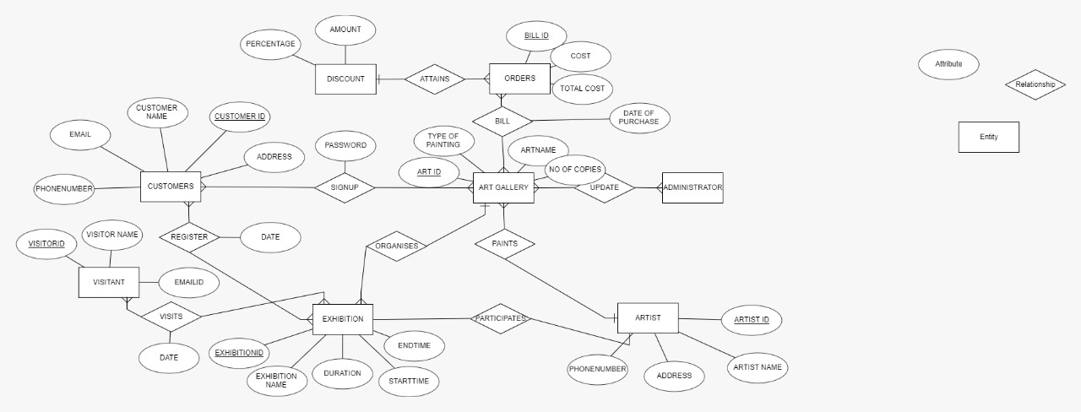

**ENTITIES**:

Customers, Art Gallery, Administration, Orders, Discount, Artist, Exhibition, Visitant

**SCHEMA:**

Customers (Email char(20) , CustomerName char(20), CustomerID int, Address char(20), PhoneNumber int)

Art Gallery (ArtID int, ArtName char(20), TypeOfPainting char(20), NumberOfCopies int)

Artists (ArtistID int, ArtistName char(20), Address char(20), PhoneNumber int)

Orders (OrderID int, Cost int, TotalCost int)

Discount (Amount int, Percentage int)

Exhibition (ExhibitionID int, ExhibitionName char(20), Duration int, Starttime int, Endtime int)

Visitant (VisitorID int, VisitorName char(20), EmailID char(20)

**ER MODEL:**





**+**

**RELATIONAL DATABASE SCHEME:**

|  |  |  |  |
| --- | --- | --- | --- |
| **ENTITY** | **RELATIONSHIP** | **ENTITY** | **CARDINALITY** |
| Customer | Signup | Art Gallery | Many to Many |
| Art Gallery | Bill | Orders | Many to Many |
| Orders | Attain | Discount | Many to one |
| Customer | Register | Exhibition | Many to many |
| Visitant | Visits | Exhibition | Many to many |
| Art Gallery | Organises | Exhibition | Many to one |
| Artist | Participates | Exhibition | Many to many |

**LOGICAL DATABASE:**

CUSTOMER TABLE:

DESC CUSTOMER;

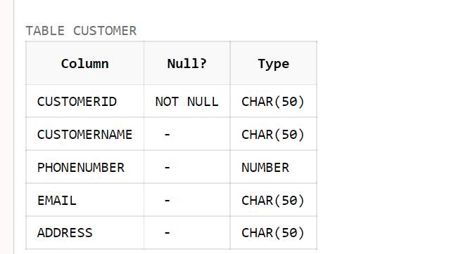

DESC ARTGALLERY;

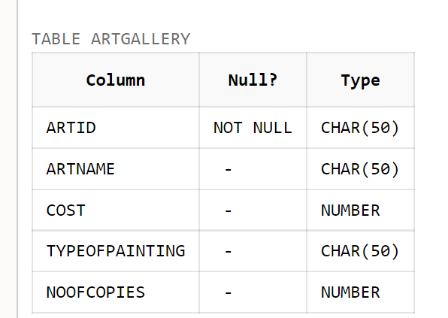

SIGNUP:

CREATE TABLE SIGNUP(CUSTOMERID CHAR(50) ,PASSWORD CHAR(50) UNIQUE,PRIMARY KEY(CUSTOMERID),FOREIGN KEY(CUSTOMERID) REFERENCES CUSTOMER,ARTID CHAR(50),FOREIGN KEY(ARTID) REFERENCES ARTGALLERY);

DESC SIGNUP;

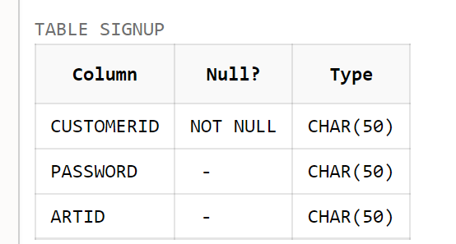

DESC ARTIST;

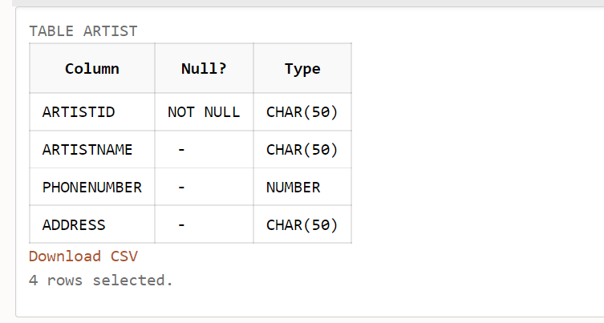

DESC PAINTS;

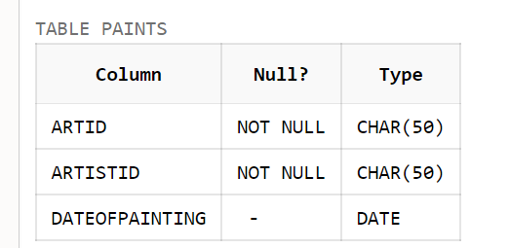

DESC ORDERS;

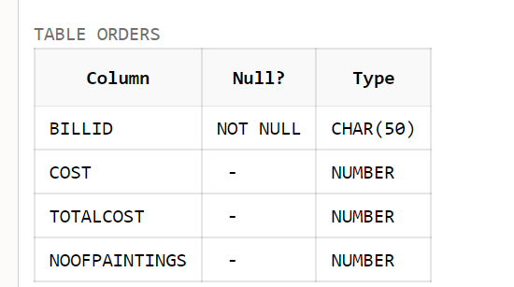

DESC ATTAINS;

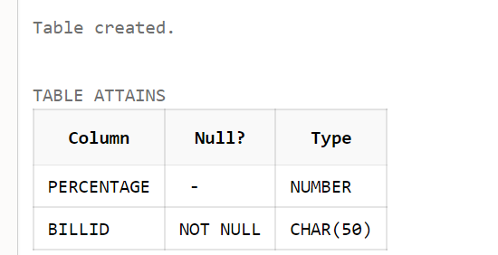

DESC BILL;

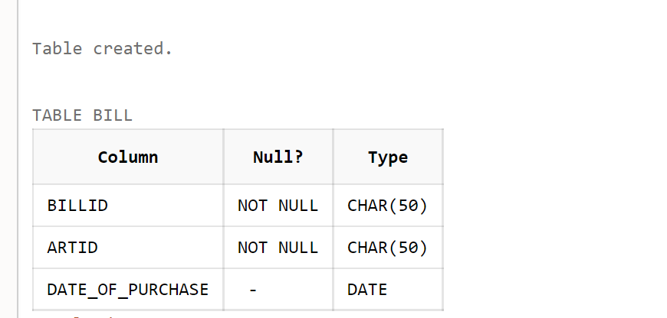

DESC DISCOUNT;

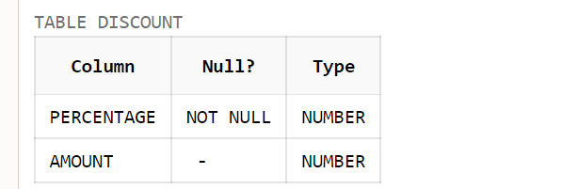

DESC VISITANT;

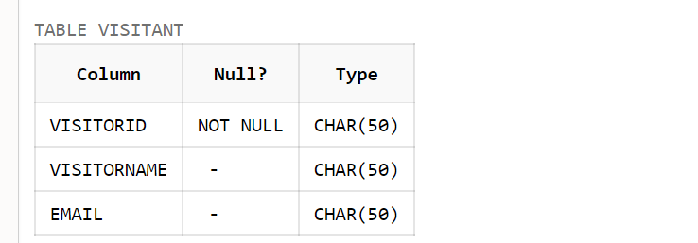

DESC VIP;

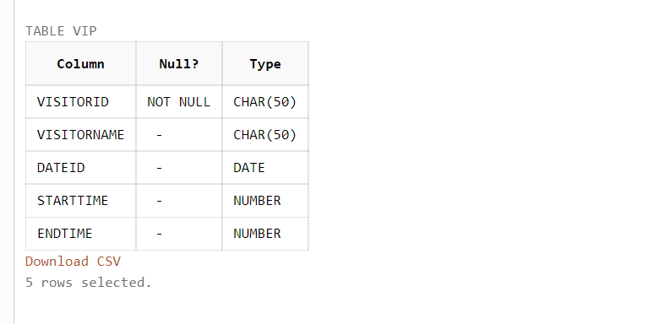

DESC NORMALVISITOR;

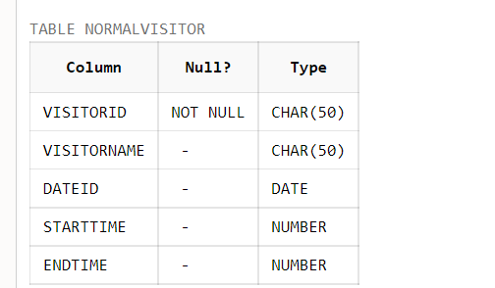

DESC EXHIBUTION;

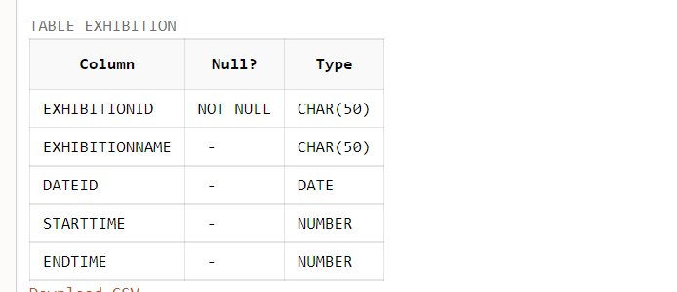

DESC ORGANISES;

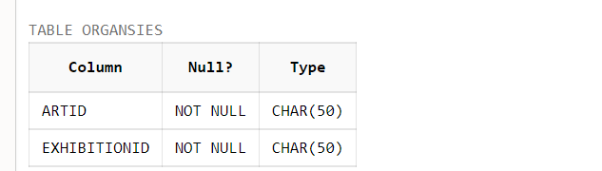

DESC REGISTER;

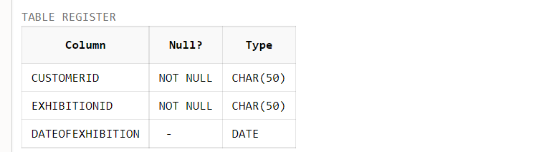

DESC PARTICIPATES;

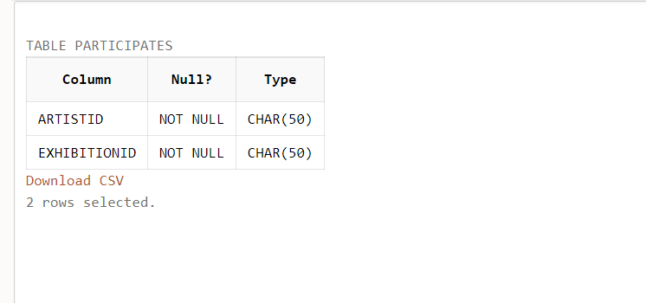

DESC VISITS;

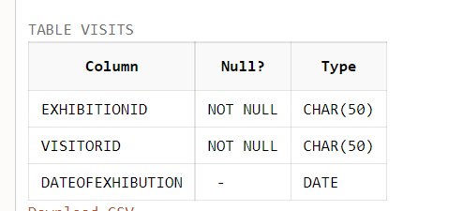

TABLES AND INSERTION SATEMENTS:

CREATE TABLE CUSTOMER(CUSTOMERID CHAR(50) PRIMARY KEY, CUSTOMERNAME CHAR(50),PHONENUMBER INT UNIQUE,EMAIL CHAR(50) UNIQUE , ADDRESS CHAR(50));

INSERT INTO CUSTOMER VALUES(101,'CHARAN',9166567094,'ABC@123.COM','KHAMMAM');

INSERT INTO CUSTOMER VALUES(102,'VISHAL',9178545409,'DBC@468.COM','VIZAG');

INSERT INTO CUSTOMER VALUES(103,'SIRISHA',838456709,'FGT@693.COM','HYDERABAD');

INSERT INTO CUSTOMER VALUES(104,'GREESHMA',9176789109,'JYBC@ML.COM','VIZAG');

INSERT INTO CUSTOMER VALUES(105,'SAI KIRAN',6301768890,'JYBCL@ML.COM','KHAMMAM');

INSERT INTO CUSTOMER VALUES(106,'NEHA',9166567088,'VVC@323.COM','HYDERABAD');

INSERT INTO CUSTOMER VALUES(107,'SRINDH',9178549940,'XYZ#499.COM','VIZAG');

INSERT INTO CUSTOMER VALUES (108,'YASASHWINI',7013537995,'CHG@66.COM','VIJAYAWADA');

INSERT INTO CUSTOMER VALUES(109,'RADHA',3987456321,'RASKS#149.COM','MUMBAI');

INSERT INTO CUSTOMER VALUES (110,'MANASA',3759632146,'VMPL@86.COM','GOA');

SELECT * FROM CUSTOMER;

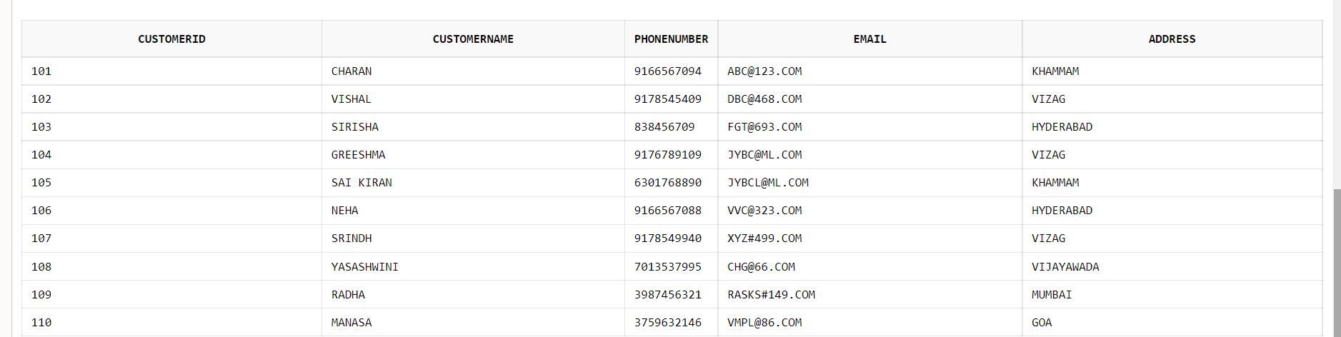

*ART GALLERY:*

CREATE TABLE ARTGALLERY(ARTID CHAR(50),ARTNAME CHAR(50) UNIQUE,COST INT,TYPEOFPAINTING CHAR(50),PRIMARY KEY(ARTID),NOOFCOPIES INT);

INSERT INTO ARTGALLERY VALUES('ART1','MONALISA',45000,'OILPAINTING',3);

INSERT INTO ARTGALLERY VALUES('ART2','PORTRAIT OF MUSICIAN',35000,'OILPAINTING',4);

INSERT INTO ARTGALLERY VALUES('ART3','MOTHERTHERESA',55000,'ABSTRACTPAINTING',3);

INSERT INTO ARTGALLERY VALUES('ART4','TALE OF THREE CITIES',65000,'CUBISMPAINTING',3);

INSERT INTO ARTGALLERY VALUES('ART5','ARJUNA AND SUBHADRA',75000,'OILPAINTING',8);

INSERT INTO ARTGALLERY VALUES('ART6','PAINTING OF GODESS SARASWATHI',55000,'ABSTRACTPAINTING',3);

INSERT INTO ARTGALLERY VALUES('ART7','SELFPORTRAIT WITH GREY FELT HAT',85000,'PORTRAITPAINTING',7);

INSERT INTO ARTGALLERY VALUES('ART8','SELFPORTRAIT WITH STRAW HAT',95000,'PORTRAITPAINTING',7);

INSERT INTO ARTGALLERY VALUES('ART9','IMPRESSION SUNSHINE',65000,'ABSTRACTPAINTING',8);

INSERT INTO ARTGALLERY VALUES('ART10','WATERLILLY POND',75000,'ABSTRACTPAINTING',9);

SELECT * FROM ARTGALLERY;

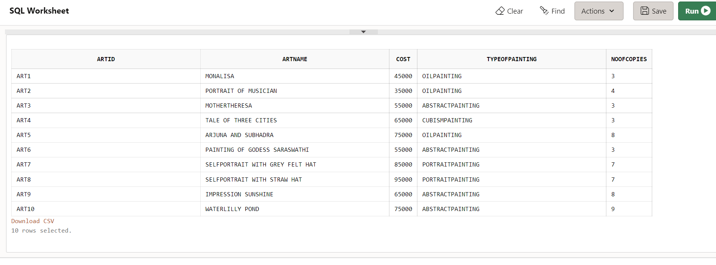

*SIGN UP TABLE:*

CREATE TABLE SIGNUP(CUSTOMERID CHAR(50) ,PASSWORD CHAR(50) UNIQUE,PRIMARY KEY(CUSTOMERID),FOREIGN KEY(CUSTOMERID) REFERENCES CUSTOMER,ARTID CHAR(50),FOREIGN KEY(ARTID) REFERENCES ARTGALLERY);

INSERT INTO SIGNUP VALUES ('101','Hskj$$45','ART2');

INSERT INTO SIGNUP VALUES ('102','Firs!!69','ART6');

INSERT INTO SIGNUP VALUES ('103','Kbv@@93','ART1');

INSERT INTO SIGNUP VALUES ('104','BMsk@@46','ART9');

INSERT INTO SIGNUP VALUES ('105','aBH$$989','ART10');

INSERT INTO SIGNUP VALUES ('106','Firs!!69','ART4');

INSERT INTO SIGNUP VALUES ('107','yLv@@321','ART2');

INSERT INTO SIGNUP VALUES ('108','HLlsk@@123','ART9');

INSERT INTO SIGNUP VALUES ('109','MYlove&&143','ART8');

INSERT INTO SIGNUP VALUES ('110','Ksk143R@','ART5');

SELECT * FROM SIGNUP;

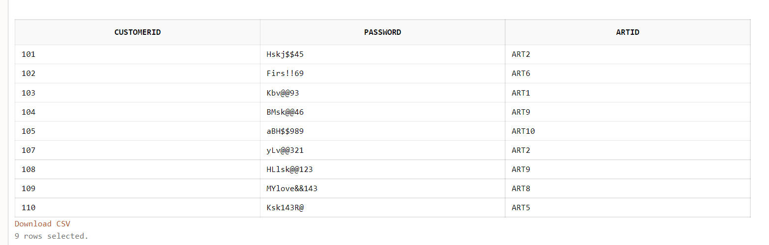

*ARTIST ID TABLE:*

CREATE TABLE ARTIST(ARTISTID CHAR(50) PRIMARY KEY,ARTISTNAME CHAR(50) UNIQUE,PHONENUMBER INT UNIQUE,ADDRESS CHAR(50));

INSERT INTO ARTIST VALUES ('A1', 'LEONARDO DAVINCI', 6352419872 , 'BANGALORE' );

INSERT INTO ARTIST VALUES ('A2', 'M.F.HUSSIAN', 8214563987 , 'CHENNAI' );

INSERT INTO ARTIST VALUES ('A3', 'RAJA RAVI VARMA', 7456321987 , 'HYDERBAD' );

INSERT INTO ARTIST VALUES ('A4', 'VANGOGH', 4563217895 , 'DELHI');

INSERT INTO ARTIST VALUES ('A5', 'CLAUDE MONET', 5467892138 , 'MUMBAI');

SELECT * FROM ARTIST;

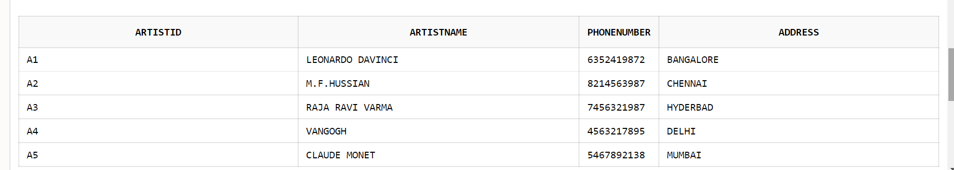

*PAINTS TABLE:*

CREATE TABLE PAINTS(ARTID CHAR(50),ARTISTID CHAR(50) ,PRIMARY KEY(ARTID,ARTISTID),DATEOFPAINTING DATE ,FOREIGN KEY(ARTID) REFERENCES ARTGALLERY ,FOREIGN KEY(ARTISTID) REFERENCES ARTIST ON DELETE CASCADE);

INSERT INTO PAINTS VALUES('ART1','A1','09-OCT-2021');

INSERT INTO PAINTS VALUES('ART2','A2','10-OCT-2021');

INSERT INTO PAINTS VALUES('ART3','A3','11-OCT-2021');

INSERT INTO PAINTS VALUES('ART4','A4','12-OCT-2021');

INSERT INTO PAINTS VALUES('ART5','A5','13-OCT-2021');

INSERT INTO PAINTS VALUES('ART6','A1','14-OCT-2021');

INSERT INTO PAINTS VALUES('ART7','A2','15-OCT-2021');

SELECT * FROM

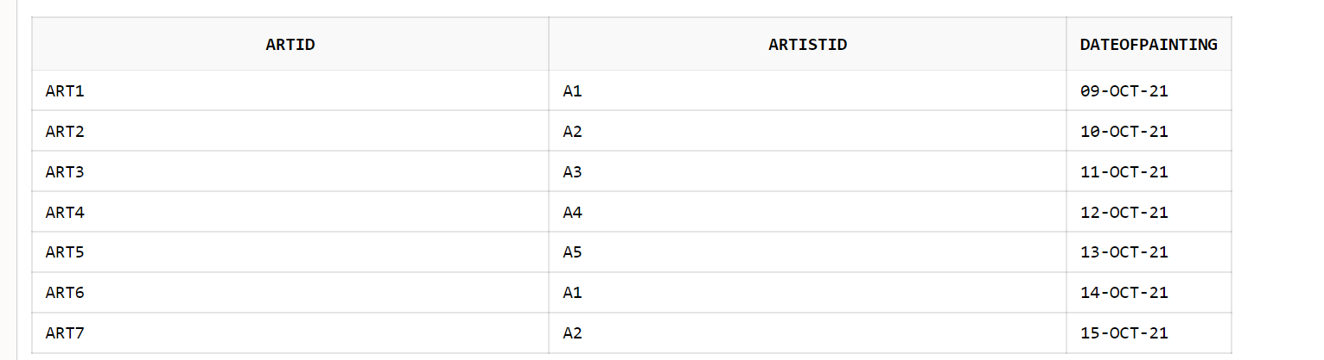

*ORDERS TABLE*:

CREATE TABLE ORDERS(BILLID CHAR(50) PRIMARY KEY,COST INT, TOTALCOST INT DEFAULT 0,NOOFPAINTINGS INT );

INSERT INTO ORDERS VALUES(12111,12000,15000,8);

INSERT INTO ORDERS VALUES(12112,13000,18000,3);

INSERT INTO ORDERS VALUES(12113,14000,25000,2);

INSERT INTO ORDERS VALUES(12114,15000,65000,7);

INSERT INTO ORDERS VALUES(12115,16000,75000,11);

INSERT INTO ORDERS VALUES(12116,17000,85000,10);

INSERT INTO ORDERS VALUES(12117,18000,75000,16);

SELECT * FROM ORDERS;

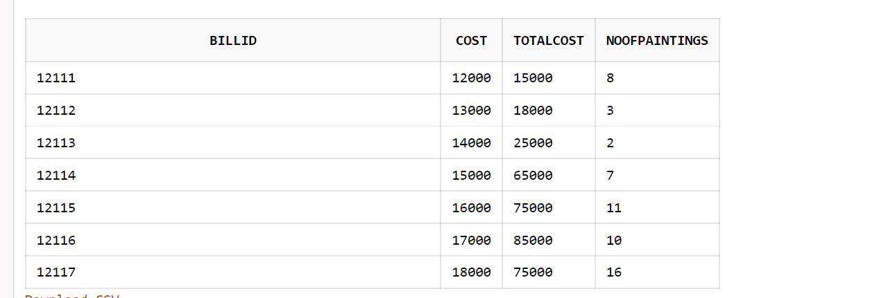

*BILL TABLE:*

CREATE TABLE BILL(BILLID CHAR(50),ARTID CHAR(50),DATE_OF_PURCHASE DATE,PRIMARY KEY(BILLID,ARTID),FOREIGN KEY(ARTID) REFERENCES ARTGALLERY,FOREIGN KEY(BILLID) REFERENCES ORDERS);

INSERT INTO BILL VALUES(12111,'ART1','12-OCT-2020');

INSERT INTO BILL VALUES(12113,'ART5','2-AUG-2021');

INSERT INTO BILL VALUES(12111,'ART2','23-SEP-2018');

INSERT INTO BILL VALUES(12114,'ART1','16-NOV-2019');

INSERT INTO BILL VALUES(12115,'ART4','18-JUN-2020');

INSERT INTO BILL VALUES(12114,'ART7','28-DEC-2020');

SELECT * FROM BILL;

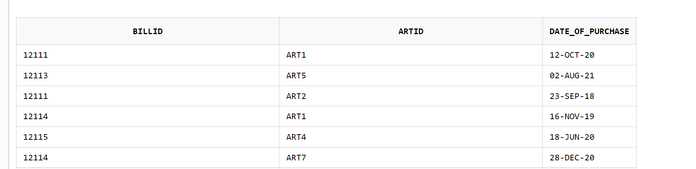

*DISCOUNT TABLE:*

CREATE TABLE DISCOUNT(PERCENTAGE INT PRIMARY KEY,AMOUNT INT UNIQUE, CHECK (PERCENTAGE<100));

INSERT INTO DISCOUNT VALUES(5,500);

INSERT INTO DISCOUNT VALUES(10,1500);

INSERT INTO DISCOUNT VALUES(20,2400);

INSERT INTO DISCOUNT VALUES(110,4500);

INSERT INTO DISCOUNT VALUES(50,5300);

INSERT INTO DISCOUNT VALUES(65,7000);

INSERT INTO DISCOUNT VALUES(75,8002);

INSERT INTO DISCOUNT VALUES(80,9000);

SELECT * FROM DISCOUNT;

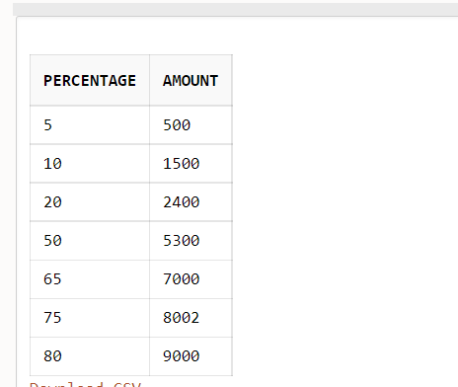

*ATTAINS TABLE:*

CREATE TABLE ATTAINS(PERCENTAGE INT ,BILLID CHAR(50),PRIMARY KEY(BILLID),FOREIGN KEY(PERCENTAGE) REFERENCES DISCOUNT,FOREIGN KEY(BILLID) REFERENCES ORDERS);

INSERT INTO ATTAINS VALUES(5,12111);

INSERT INTO ATTAINS VALUES(10,12113);

INSERT INTO ATTAINS VALUES(5,12114);

INSERT INTO ATTAINS VALUES(20,12116);

SELECT * FROM ATTAINS;

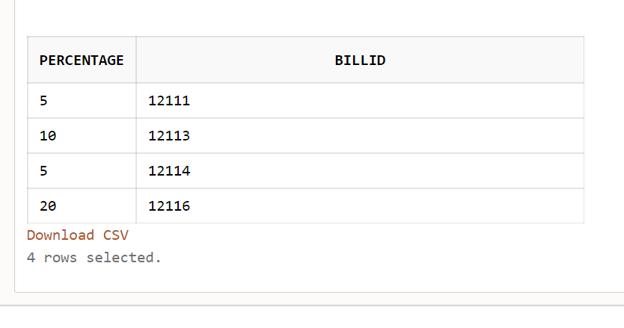

*VISITANT TABLE:*

CREATE TABLE VISITANT(VISITORID CHAR(50),VISITORNAME CHAR(50),PRIMARY KEY(VISITORID),EMAIL CHAR(50));

INSERT INTO VISITANT VALUES('1234A','MEENA','MEENA@GMAIL.COM');

INSERT INTO VISITANT VALUES('1234B','RAMU','RAMU@GMAIL.COM');

INSERT INTO VISITANT VALUES('1234C','BHANU','BHANU@GMAIL.COM');

INSERT INTO VISITANT VALUES('1234D','SRAVYA','SRAVYA@GMAIL.COM');

INSERT INTO VISITANT VALUES('1234E','NANI','NANI@GMAIL.COM');

INSERT INTO VISITANT VALUES('1234F','MALLI','MALLI@GMAIL.COM');

INSERT INTO VISITANT VALUES('1234G','HARITHA','HARITHA@GMAIL.COM');

INSERT INTO VISITANT VALUES('1234H','LASKSHI','LASKHMI@GMAIL.COM');

INSERT INTO VISITANT VALUES('1234I','NARAYA','NARAYA@GMAIL.COM');

INSERT INTO VISITANT VALUES('1234J','BABU','BABU@GMAIL.COM');

INSERT INTO VISITANT VALUES('1234K','UDAYA','UDAYA@GMAIL.COM');

INSERT INTO VISITANT VALUES('1234L','KARNTHI','KRANTHI@GMAIL.COM');

SELECT * FROM VISITANT;

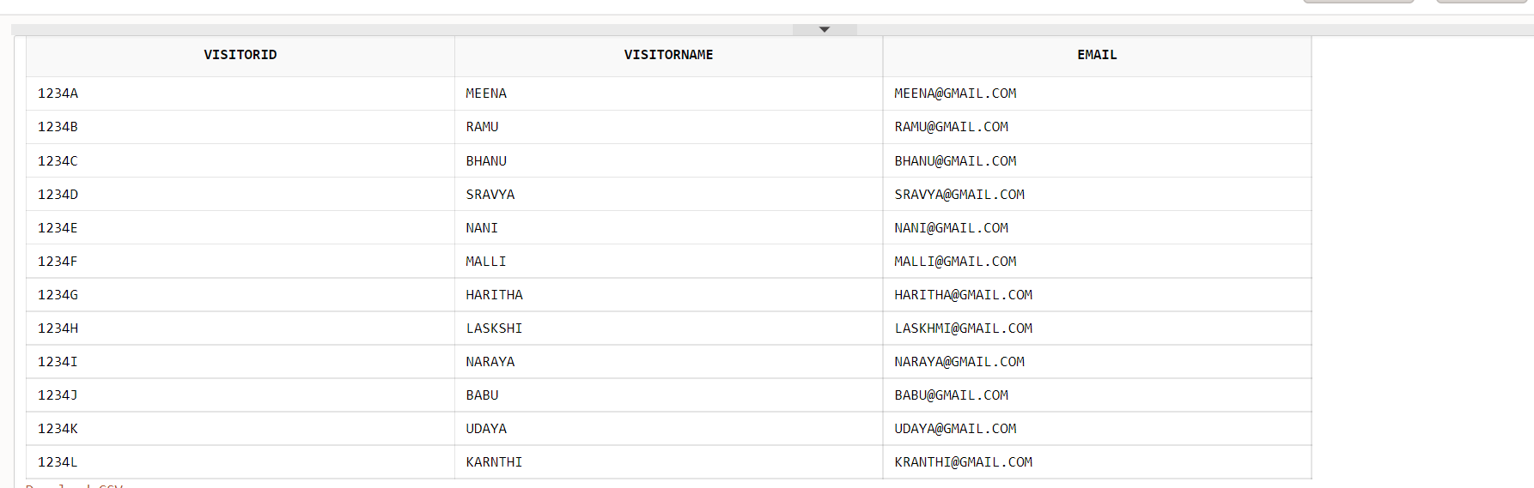

*VIP TABLE:*

CREATE TABLE VIP(VISITORID CHAR(50),VISITORNAME CHAR(50),FOREIGN KEY(VISITORID) REFERENCES VISITANT,DATEID DATE,STARTTIME INT,ENDTIME INT,PRIMARY KEY(VISITORID),CHECK (ENDTIME<24),CHECK(STARTTIME<24),CHECK ((ENDTIME-STARTTIME)<4));

INSERT INTO VIP VALUES('1234A','MEENA','21-OCT-2021',9,12);

INSERT INTO VIP VALUES('1234C','BHANU','30-AUG-2018',12,15);

INSERT INTO VIP VALUES('1234F','MALLI','23-JAN-2019',18,20);

INSERT INTO VIP VALUES('1234G','HARITHA','02-MAY-2020',21,23);

INSERT INTO VIP VALUES('1234E','NANI','11-APR-2017',11,14);

SELECT * FROM VIP;

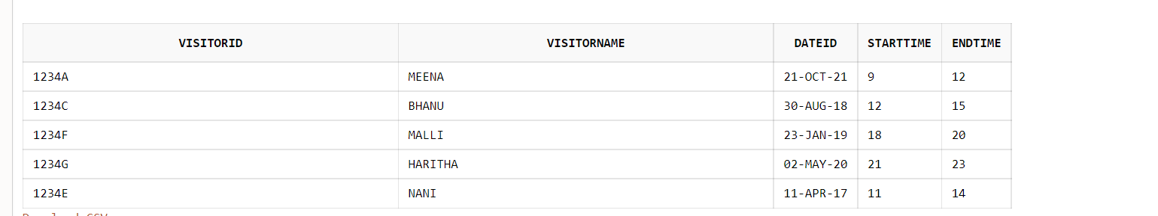

*NORMAL VISITOR TABLE:*

CREATE TABLE NORMALVISITOR(VISITORID CHAR(50),VISITORNAME CHAR(50),FOREIGN KEY(VISITORID) REFERENCES VISITANT,DATEID DATE,STARTTIME INT,ENDTIME INT,PRIMARY KEY(VISITORID),CHECK (ENDTIME<24),CHECK(STARTTIME<24));

INSERT INTO NORMALVISITOR VALUES('1234B','RAMU','21-OCT-2021',14,20);

INSERT INTO NORMALVISITOR VALUES('1234D','SRAVYA','04-AUG-2018',16,23);

INSERT INTO NORMALVISITOR VALUES('1234L','KRANTHI','13-NOV-2020',9,16);

INSERT INTO NORMALVISITOR VALUES('1234H','LASKSHI','23-JAN-2019',7,14);

INSERT INTO NORMALVISITOR VALUES('1234I','NARAYA','02-MAY-2020',10,15);

INSERT INTO NORMALVISITOR VALUES('1234J','BABU','11-APR-2017',15,23);

SELECT * FROM NORMALVISITOR;

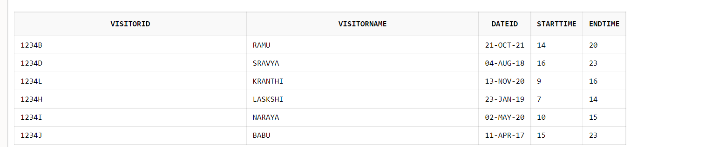

*EXHIBITION TABLE:*

CREATE TABLE EXHIBITION(EXHIBITIONID CHAR(50) PRIMARY KEY,EXHIBITIONNAME CHAR(50) UNIQUE,DATEID DATE UNIQUE,STARTTIME INT,ENDTIME INT,CHECK ((ENDTIME-STARTTIME)>0),CHECK (STARTTIME<24 AND ENDTIME<24))

INSERT INTO EXHIBITION VALUES('6789','CRAZYARTS','09-OCT-2021',10,23);

INSERT INTO EXHIBITION VALUES('6790','FINEARTS','19-OCT-2021',11,23);

INSERT INTO EXHIBITION VALUES('6791','DELIGHTSTUDIO','29-OCT-2021',12,22);

INSERT INTO EXHIBITION VALUES('6792','ARTISTICMOVES','09-NOV-2021',13,22);

INSERT INTO EXHIBITION VALUES('6793','PLATINUMGALLERY','29-NOV-2021',14,21);

INSERT INTO EXHIBITION VALUES('6794','ABSTRACTACTS','09-DEC-2021',15,23);

INSERT INTO EXHIBITION VALUES('6795','CREATIVEARTS','09-FEB-2021',16,22);

INSERT INTO EXHIBITION VALUES('6796','COLLECTIVEARTS','09-APR-2021',17,23);

INSERT INTO EXHIBITION VALUES('6797','DREAMARTS','09-JAN-2021',18,22);

SELECT * FROM EXHIBITION;

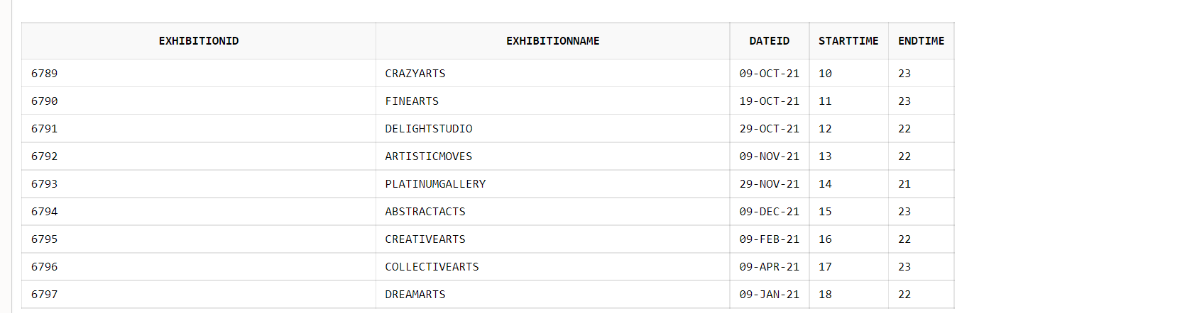

*REGISTER TABLE:*

CREATE TABLE REGISTER(CUSTOMERID CHAR(50),EXHIBITIONID CHAR(50),PRIMARY KEY(CUSTOMERID,EXHIBITIONID),DATEOFEXHIBITION DATE ,FOREIGN KEY(CUSTOMERID) REFERENCES CUSTOMER,FOREIGN KEY(EXHIBITIONID) REFERENCES EXHIBITION);

INSERT INTO REGISTER VALUES(101,'6789','09-OCT-2021');

INSERT INTO REGISTER VALUES(101,'6791','29-OCT-2021');

INSERT INTO REGISTER VALUES(105,'6789','09-OCT-2021');

INSERT INTO REGISTER VALUES(101,'6796','09-APR-2021');

INSERT INTO REGISTER VALUES(104,'6797','09-JAN-2021');

INSERT INTO REGISTER VALUES(107,'6795','09-FEB-2021');

INSERT INTO REGISTER VALUES(104,'6796','09-APR-2021');

SELECT * FROM REGISTER;

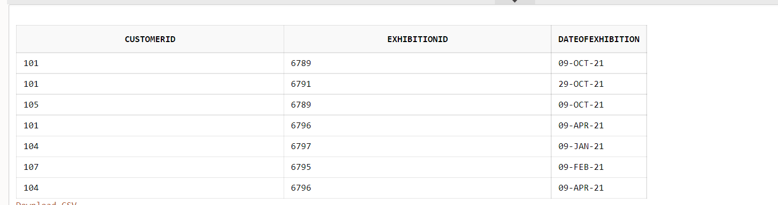

*ORGANISE TABLE:*

CREATE TABLE ORGANSIES(ARTID CHAR(50),EXHIBITIONID CHAR(50),PRIMARY KEY(EXHIBITIONID,ARTID),FOREIGN KEY(ARTID) REFERENCES ARTGALLERY ON DELETE CASCADE,FOREIGN KEY(EXHIBITIONID) REFERENCES EXHIBITION);

INSERT INTO ORGANSIES VALUES('ART1','6789');

INSERT INTO ORGANSIES VALUES('ART2','6790');

INSERT INTO ORGANSIES VALUES('ART1','6790');

INSERT INTO ORGANSIES VALUES('ART5','6791');

INSERT INTO ORGANSIES VALUES('ART3','6794');

INSERT INTO ORGANSIES VALUES('ART4','6789');

INSERT INTO ORGANSIES VALUES('ART3','6789');

INSERT INTO ORGANSIES VALUES('ART5','6793');

INSERT INTO ORGANSIES VALUES('ART6','6794');

INSERT INTO ORGANSIES VALUES('ART4','6794');

INSERT INTO ORGANSIES VALUES('ART7','6793');

INSERT INTO ORGANSIES VALUES('ART6','6793');

SELECT * FROM ORGANSIES;

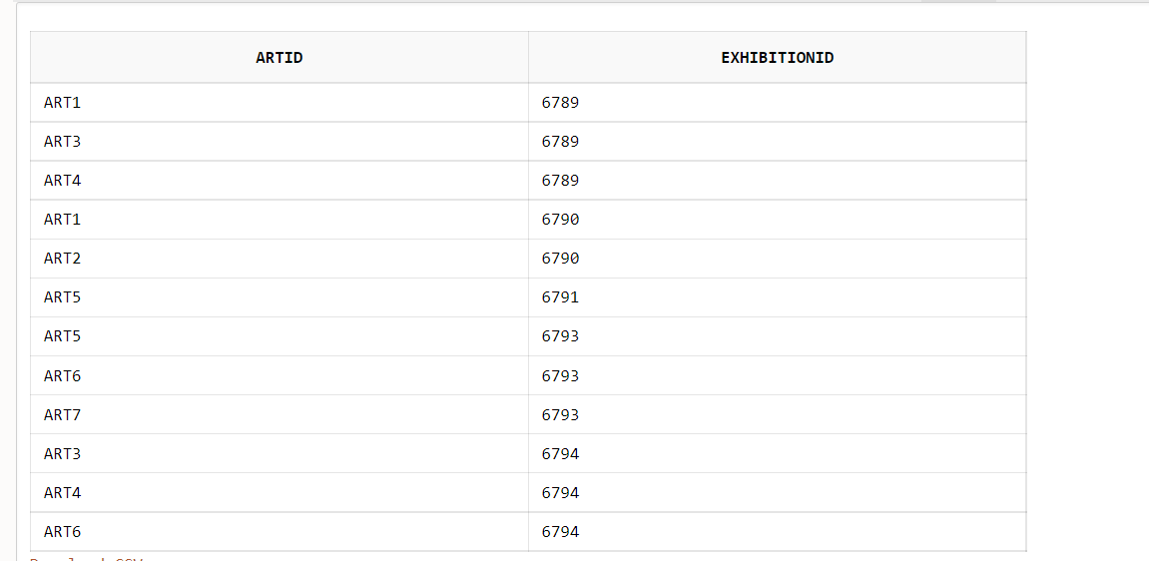

*PARTICIPANTS TABLE:*

CREATE TABLE PARTICIPATES(ARTISTID CHAR(50),EXHIBITIONID CHAR(50),PRIMARY KEY(ARTISTID,EXHIBITIONID),FOREIGN KEY(ARTISTID) REFERENCES ARTIST ON DELETE CASCADE,FOREIGN KEY(EXHIBITIONID) REFERENCES EXHIBITION);

INSERT INTO PARTICIPATES VALUES('A1','6789');

INSERT INTO PARTICIPATES VALUES('A5','6790');

INSERT INTO PARTICIPATES VALUES('A2','6789');

INSERT INTO PARTICIPATES VALUES('A5','6794');

INSERT INTO PARTICIPATES VALUES('A4','6793');

INSERT INTO PARTICIPATES VALUES('A1','6791');

INSERT INTO PARTICIPATES VALUES('A3','6794');

INSERT INTO PARTICIPATES VALUES('A5','6795');

INSERT INTO PARTICIPATES VALUES('A4','6794');

INSERT INTO PARTICIPATES VALUES('A3','6791');

SELECT * FROM PARTICIPATES;

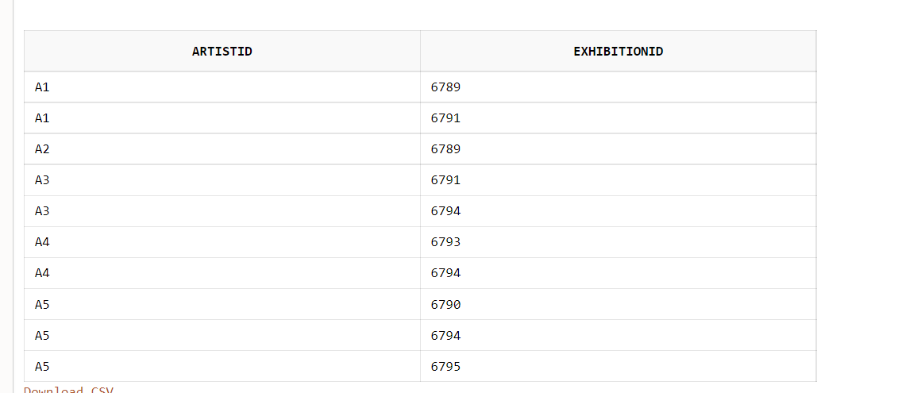

CREATE TABLE VISITS(EXHIBITIONID CHAR(50),VISITORID CHAR(50),DATEOFEXHIBUTION DATE ,PRIMARY KEY(EXHIBITIONID,VISITORID),FOREIGN KEY(EXHIBITIONID) REFERENCES EXHIBITION,FOREIGN KEY(VISITORID) REFERENCES VISITANT);

INSERT INTO VISITS VALUES('6789','1234A','09-OCT-2021');

INSERT INTO VISITS VALUES('6789','1234B','09-OCT-2021');

INSERT INTO VISITS VALUES('6790','1234C','19-OCT-2021');

INSERT INTO VISITS VALUES('6790','1234E','19-OCT-2021');

INSERT INTO VISITS VALUES('6791','1234A','29-OCT-2021');

INSERT INTO VISITS VALUES('6792','1234C','09-NOV-2021');

INSERT INTO VISITS VALUES('6796','1234D','09-APR-2021');

INSERT INTO VISITS VALUES('6796','1234F','09-APR-2021');

SELECT * FROM VISITS;

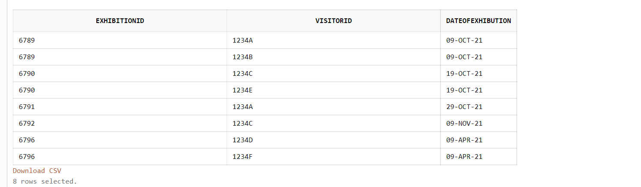

**TRIGGER:**

//TRIGGER FOR DECREASED NO OF COPIES//

CREATE OR REPLACE TRIGGER DECREASECOPIES BEFORE INSERT ON BILL FOR EACH ROW

BEGIN

UPDATE ARTGALLERY SET NOOFCOPIES=NOOFCOPIES-1 WHERE :NEW.ARTID=ARTID;

END;

//TRIGGER FOR VIP///

CREATE OR REPLACE TRIGGER DURATIONCHECK1 BEFORE INSERT ON VIP FOR EACH ROW

BEGIN

IF((:NEW.ENDTIME>:NEW.STARTTIME)) THEN

DBMS_OUTPUT.PUT_LINE('VALID START TIME');

ELSE

RAISE_APPLICATION_ERROR(-20146,'INVAID START AND END TIME');

END IF;

END;

// TRIGGER FOR CUSTOMER TABLE \\

CREATE OR REPLACE TRIGGER PHONECHECK11 BEFORE INSERT ON CUSTOMER FOR EACH ROW

BEGIN

IF (TRUNC(1/LOG(:NEW.PHONENUMBER, 10)) + 1)=10 THEN

IF (:NEW.EMAIL LIKE '_%@_%._%') THEN

DBMS_OUTPUT.PUT_LINE('ACCEPTED PHONE NUMBER AND PHONE NUMBER');

ELSIF ( LENGTH(TO_CHAR(:NEW.PHONENUMBER))=10 AND (:NEW.EMAIL NOT LIKE '_%@_%._%')) THEN

RAISE_APPLICATION_ERROR(-20145,'INVAID EMAIL AND ACCEPTED PHONE NUMBER');

ELSIF ((:NEW.EMAIL LIKE '_%@_%._%') AND (LENGTH(TO_CHAR(:NEW.PHONENUMBER))>10 OR LENGTH(TO_CHAR(:NEW.PHONENUMBER))<10)) THEN

RAISE_APPLICATION_ERROR(-20148,'VALID EMAIL AND INVALID PHONE NUMBER');

ELSE

RAISE_APPLICATION_ERROR(-20149,'INVALID EMAIL AND INVALID PHONE NUMBER');

END IF;

END IF;

END;

//TRIGGER TO ACCEPT THE ORDER//

CREATE OR REPLACE TRIGGER TOT_COST1 BEFORE INSERT ON ORDERS FOR EACH ROW

BEGIN

IF (:NEW.TOTALCOST>=:NEW.COST) THEN

DBMS_OUTPUT.PUT_LINE('ACCEPT THE ORDERS');

ELSE

RAISE_APPLICATION_ERROR(-20145,'DO NOT ACCEPT THE ORDER');

END IF;

END;

**SCHEMA REFINEMENT:**

**NORMALIZATION:**

Normalisation or Schema Refinement is a technique of organizing the data in the database. It is a systematic approach of decomposing tables to eliminate data redundancy and undesirable characteristics like Insertion, Update and Deletion Anomalies.

**DEPENDENCIES:**

1**.** A full functional dependency is a state of database normalization that equates to the normalization standard of Second Normal Form (2NF). In brief, this means that it meets the requirements of First Normal Form (1NF), and all non-key attributes are fully functionally dependent on the primary key.

2. Partial Dependency occurs when a non-prime attribute is functionally dependent on part of a candidate key. The 2nd Normal Form (2NF) eliminates the Partial Dependency.

3. A transitive dependency in a database is an indirect relationship between values in the same table that causes a functional dependency. To achieve the normalization standard of Third Normal Form (3NF), you must eliminate any transitive dependency.

4.The Trivial dependency is a set of attributes which are called a trivial if the set of attributes are included in that attribute. So, X -> Y is a trivial functional dependency if Y is a subset of X.

5. Non Trivial Functional Dependency ,Functional dependency which also known as a nontrivial dependency occurs when A->B holds true where B is not a subset of A. In a relationship, if attribute B is not a subset of attribute A, then it is considered as a non-trivial dependency.

**KEYS:**

1.PRIMARY KEY

primary key is a column of a table or a set of columns that helps to identify every record present in that table uniquely. There can be only one primary Key in a table. Also, the primary Key cannot have the same values repeating for any row. Every value of the primary key has to be different with no repetitions

2.SUPER KEY

super key with no redundant attribute is known as candidate key. Candidate keys are selected from the set of super keys, the only thing we take care while selecting candidate key is that the candidate key should not have any redundant attributes.

**CUSTOMER**:

FUNCTIONAL DEPENDENCY:

CUSTOMERID🡪CUSTOMERNAME

CUSTOMERID🡪PHONENUMBER

CUSTOMERID🡪EMAILID

CUSTOMERID🡪ADDRESS

KEY ATTRIBUTES:CUSTOMERID

Here we need to check whether the given dependency are in 1nf ,2nf,3nf

INF:

The given dependencies are in 1nf because all the dependencies are single valued they did not have any multi valued

2NF:

To say that the functional dependencies arein 2nf ,intially they should in 1nf and no partial dependency.here in the above fd’s there is no partial dependency because the fd’s are mapped from key attribute to the non key attribute.so it is in 2nf.

3NF:

To say that the fd’s are in 3nf ,it should be in 2nf and no transitive property.form the above fd’s, there is no transitive property because as no other non key from key is not determining the other non key as a🡪b and b🡪c then this is a transitive property.

**ART GALLERY:**

FUCTIONAL DEPENDENCIES:

ARTID🡪ARTNAME

ARTID🡪TYPEOFPAINTING

TYPEOFPAINTING🡪COST

KEY ATTRIBUTES:ARTID

INF:

The given dependencies are in 1nf because all the dependencies are single valued they did not have any multi valued

2NF:

To say that the functional dependencies are in 2nf ,initially they should in 1nf and no partial dependency. Here in the above fd’s there is no partial dependency because the fd’s are mapped from key attribute to the non key attribute.so it is in 2nf.

3NF:

To say that the fd’s are in 3nf ,it should be in 2nf and no transitive property. Form the above fd’s, there is transitive property

ARTID🡪TYPEOFPAINTING

TYPEOFPAINTING🡪COST

For these dependencies there is a transitive property.so we need to decomposition of table occurs to remove the transitive property.

We decompose the table in to two parts:

Artid,artname,typeofpainting in one table and typeofpainting,cost in one table

Then by this transitive property removes

Loseless,dependency and foreign key are should be reserved

So it is in 3nf

**SIGNUP:**

CUSTOMERID🡪PASSWORD

CUSTOMERID🡪ARTID

KEYATTRIBUTES:CUSTOMERID

INF:

The given dependencies are in 1nf because all the dependencies are single valued they did not have any multi valued

2NF:

To say that the functional dependencies arein 2nf ,intially they should in 1nf and no partial dependency.here in the above fd’s there is no partial dependency because the fd’s are mapped from key attribute to the non key attribute.so it is in 2nf.

3NF:

To say that the fd’s are in 3nf ,it should be in 2nf and no transitive property.form the above fd’s, there is no transitive property because as no other non key from key is not determining the other non key as a🡪b and b🡪c then this is a transitive property.

**ARTIST:**

ARTISTID🡪ARTISTNAME

ARTISTID🡪PHONENUMBER

ARTISTID🡪ADDRESS

KEYATTIBUTES:ARTISTID

INF:

The given dependencies are in 1nf because all the dependencies are single valued they did not have any multi valued

2NF:

To say that the functional dependencies arein 2nf ,intially they should in 1nf and no partial dependency.here in the above fd’s there is no partial dependency because the fd’s are mapped from key attribute to the non key attribute.so it is in 2nf.

3NF:

To say that the fd’s are in 3nf ,it should be in 2nf and no transitive property.form the above fd’s, there is no transitive property because as no other non key from key is not determining the other non key as a🡪b and b🡪c then this is a transitive property.

**PAINTS:**

ARTISTID,ARTID🡪DATEOFPAINTING

COMPOSITE KEY:ARTISTID,ARTID

INF:

The given dependencies are in 1nf because all the dependencies are single valued they did not have any multi valued

2NF:

To say that the functional dependencies arein 2nf ,intially they should in 1nf and no partial dependency.here in the above fd’s there is no partial dependency because the fd’s are mapped from key attribute to the non key attribute.so it is in 2nf.

3NF:

To say that the fd’s are in 3nf ,it should be in 2nf and no transitive property.form the above fd’s, there is no transitive property because as no other non key from key is not determining the other non key as a🡪b and b🡪c then this is a transitive property.

**BILL:**

BILLID,ARTID🡪DATE

COMPOSITE KEY: BILLID,ARTID

INF:

The given dependencies are in 1nf because all the dependencies are single valued they did not have any multi valued

2NF:

To say that the functional dependencies arein 2nf ,intially they should in 1nf and no partial dependency.here in the above fd’s there is no partial dependency because the fd’s are mapped from key attribute to the non key attribute.so it is in 2nf.

3NF:

To say that the fd’s are in 3nf ,it should be in 2nf and no transitive property.form the above fd’s, there is no transitive property because as no other non key from key is not determining the other non key as a🡪b and b🡪c then this is a transitive property.

**ORDERS:**

BILLID🡪COST

BILLID🡪NOOFPAINTING

KEY ATTRIBUTES:BILLID

INF:

The given dependencies are in 1nf because all the dependencies are single valued they did not have any multi valued

2NF:

To say that the functional dependencies arein 2nf ,intially they should in 1nf and no partial dependency.here in the above fd’s there is no partial dependency because the fd’s are mapped from key attribute to the non key attribute.so it is in 2nf.

3NF:

To say that the fd’s are in 3nf ,it should be in 2nf and no transitive property.form the above fd’s, there is no transitive property because as no other non key from key is not determining the other non key as a🡪b and b🡪c then this is a transitive property.

**DISCOUNTS:**

PERCENTAGE:AMOUNT

KEY ATTIBUTES: PERCENTAGE

INF:

The given dependencies are in 1nf because all the dependencies are single valued they did not have any multi valued

2NF:

To say that the functional dependencies arein 2nf ,intially they should in 1nf and no partial dependency.here in the above fd’s there is no partial dependency because the fd’s are mapped from key attribute to the non key attribute.so it is in 2nf.

3NF:

To say that the fd’s are in 3nf ,it should be in 2nf and no transitive property.form the above fd’s, there is no transitive property because as no other non key from key is not determining the other non key as a🡪b and b🡪c then this is a transitive property.

**ATTAINS:**

BILLID🡪PERCENTAGE

KEY ATTRIBUTES:BILLID

INF:

The given dependencies are in 1nf because all the dependencies are single valued they did not have any multi valued

2NF:

To say that the functional dependencies are in 2nf , initially they should in 1nf and no partial dependency. here in the above fd’s there is no partial dependency because the fd’s are mapped from key attribute to the non key attribute.so it is in 2nf.

3NF:

To say that the fd’s are in 3nf ,it should be in 2nf and no transitive property.form the above fd’s, there is no transitive property because as no other non key from key is not determining the other non key as a🡪b and b🡪c then this is a transitive property.

**VISITANT:**

VISITORID🡪VISITIOTNAME

VISITORID🡪EMAIL

KEY ATTRIBUTE:VISITORID

INF:

The given dependencies are in 1nf because all the dependencies are single valued they did not have any multi valued

2NF:

To say that the functional dependencies arein 2nf ,intially they should in 1nf and no partial dependency.here in the above fd’s there is no partial dependency because the fd’s are mapped from key attribute to the non key attribute.so it is in 2nf.

3NF:

To say that the fd’s are in 3nf ,it should be in 2nf and no transitive property.form the above fd’s, there is no transitive property because as no other non key from key is not determining the other non key as a🡪b and b🡪c then this is a transitive property.

**VIP:**

VISITORID🡪VISITORNAME

VISITORID🡪DATE

VISITORID🡪ENDTIME

VISTIORID🡪STARTTIME

KEY ATTIBUTES: VISITORID

INF:

The given dependencies are in 1nf because all the dependencies are single valued they did not have any multi valued

2NF:

To say that the functional dependencies arein 2nf ,intially they should in 1nf and no partial dependency.here in the above fd’s there is no partial dependency because the fd’s are mapped from key attribute to the non key attribute.so it is in 2nf.

3NF:

To say that the fd’s are in 3nf ,it should be in 2nf and no transitive property.form the above fd’s, there is no transitive property because as no other non key from key is not determining the other non key as a🡪b and b🡪c then this is a transitive property.

**NORMALVISITOR:**

VISITORID🡪VISITORNAME

VISITORID🡪DATE

VISITORID🡪ENDTIME

VISTIORID🡪STARTTIME

KEY ATTIBUTES: VISITORID

INF:

The given dependencies are in 1nf because all the dependencies are single valued they did not have any multi valued

2NF:

To say that the functional dependencies arein 2nf ,Intially they should in 1nf and no partial dependency. here in the above fd’s there is no partial dependency because the fd’s are mapped from key attribute to the non key attribute.so it is in 2nf.

3NF:

To say that the fd’s are in 3nf ,it should be in 2nf and no transitive property. form the above fd’s, there is no transitive property because as no other non key from key is not determining the other non key as a🡪b and b🡪c then this is a transitive property.

**EXHIBITION:**

EXHIBITIONID🡪EXHIBITIONNAME

EXHIBITIONID🡪DATE

EXHIBITIONID🡪STARTTIME

EXHIBITIONID🡪ENDTIME

KEY ATTRIBUTES:EXHIBITIONID

INF:

The given dependencies are in 1nf because all the dependencies are single valued they did not have any multi valued

2NF:

To say that the functional dependencies arein 2nf ,intially they should in 1nf and no partial dependency.here in the above fd’s there is no partial dependency because the fd’s are mapped from key attribute to the non key attribute.so it is in 2nf.

3NF:

To say that the fd’s are in 3nf ,it should be in 2nf and no transitive property.form the above fd’s, there is no transitive property because as no other non key from key is not determining the other non key as a🡪b and b🡪c then this is a transitive property.

**VISITS:**

EXHIBITIONID,VISITORID🡪DATEOFEXHIBITION

KEY ATTRIBUTES: EXHIBITIONID,VISITORID

INF:

The given dependencies are in 1nf because all the dependencies are single valued they did not have any multi valued

2NF:

To say that the functional dependencies arein 2nf ,intially they should in 1nf and no partial dependency.here in the above fd’s there is no partial dependency because the fd’s are mapped from key attribute to the non key attribute.so it is in 2nf.

3NF:

To say that the fd’s are in 3nf ,it should be in 2nf and no transitive property.form the above fd’s, there is no transitive property because as no other non key from key is not determining the other non key as a🡪b and b🡪c then this is a transitive property.

**REGISTER**:

REGISTERID🡪DATEOFEXHIBUTION

KEY ATTIBUTES:REGISTERID

INF:

The given dependencies are in 1nf because all the dependencies are single valued they did not have any multi valued

2NF:

To say that the functional dependencies arein 2nf ,intially they should in 1nf and no partial dependency.here in the above fd’s there is no partial dependency because the fd’s are mapped from key attribute to the non key attribute.so it is in 2nf.

3NF:

To say that the fd’s are in 3nf ,it should be in 2nf and no transitive property.form the above fd’s, there is no transitive property because as no other non key from key is not determining the other non key as a🡪b and b🡪c then this is a transitive property.

**QUERIES:**

1.NUMBER OF VIP IN VISITANT ON THE '9TH 0CTOBER 2021 ?

Query :

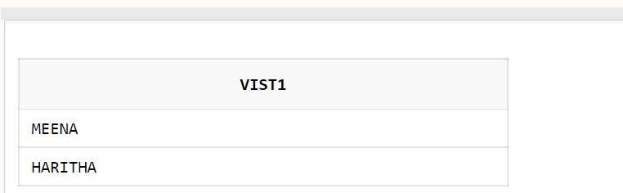SELECT V.VISITORNAME AS VIST1 FROM VIP V,VISITANT S,VISITS I WHERE V.VISITORID=S.VISITORID AND S.VISITORID=I.VISITORID AND I.DATEOFEXHIBITION='9-OCT-2021'

2. ARTIST NAMES,ARTID WHO DRAW OILPAINTING ?

Query:

SELECT ARTID,ARTNAME FROM ARTGALLERY WHERE TYPEOFPAINTING ='OILPAINTING';

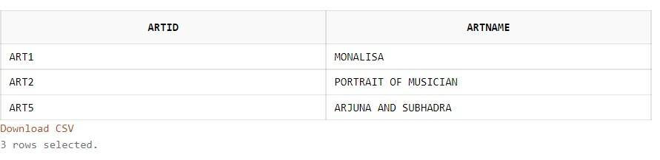

3. NUMBER OF CUSTOMER WHO BELONG TO ADDRESS HYDERABAD AND NAME START WITH N ?

Query :

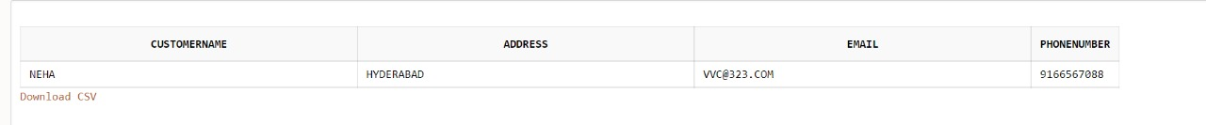SELECT C.CUSTOMERNAME,C.ADDRESS,C.EMAIL,C.PHONENUMBER FROM CUSTOMER C WHERE C.ADDRESS='HYDERABAD' AND C.CUSTOMERNAME LIKE 'N%';

4. NUMBER OF CUSTOMERS AND DEATILS WHO NOT LIVES IN VIZAG ?

Query :

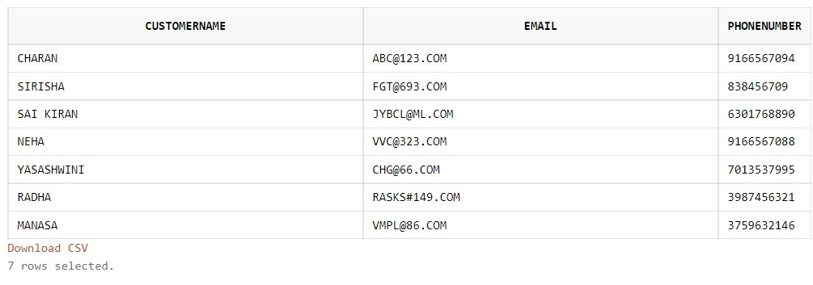SELECT CUSTOMERNAME,EMAIL,PHONENUMBER FROM CUSTOMER WHERE NOT ADDRESS = 'VIZAG';

5. VISITOR DETAILS WHO HAS VISITIED THE EXIHIBITION THE MOST ?

Query :

SELECT * FROM REGISTER WHERE CUSTOMERID IN ('101','104');

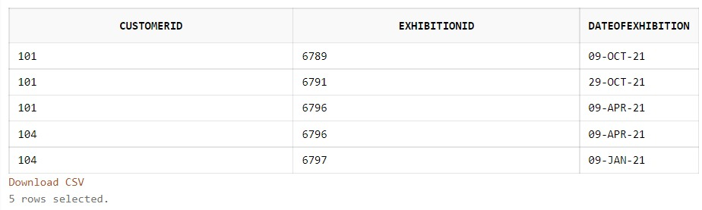

6. NUMBER OF VISITORS AND DEATAILS WHO HAS VISITED BUT EXCEPT IN JAN 2021 TO DEC 2021 ?

QUERY :

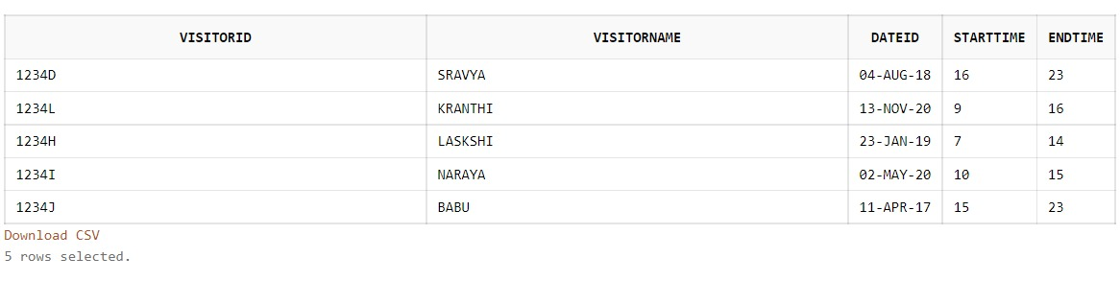SELECT * FROM NORMALVISITOR WHERE DATEID NOT BETWEEN '01-JAN-2021' AND '30-DEC-2021';

7. PAINTINGS WHICH WAS SOLD FROM ARY GALLERY ?

QUERY:

SELECT ARTID,ARTNAME,TYPEOFPAINTING FROM ARTGALLERY A WHERE EXISTS (SELECT * FROM BILL B WHERE A.ARTID=B.ARTID GROUP BY BILLID);

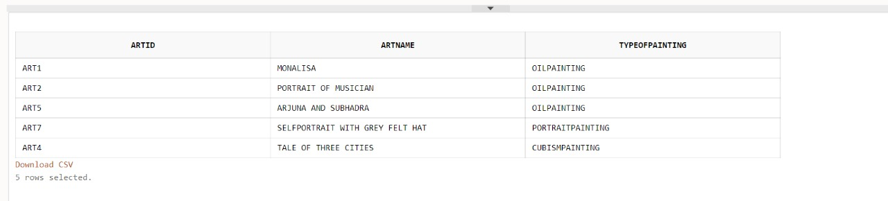

8. QUERY BETWEEN PAINTS AND ART GALLERY BY USING JOINS

QUERY :

SELECT * FROM PAINTS FULL OUTER JOIN ARTGALLERY ON ARTGALLERY.ARTID = PAINTS.ARTID;

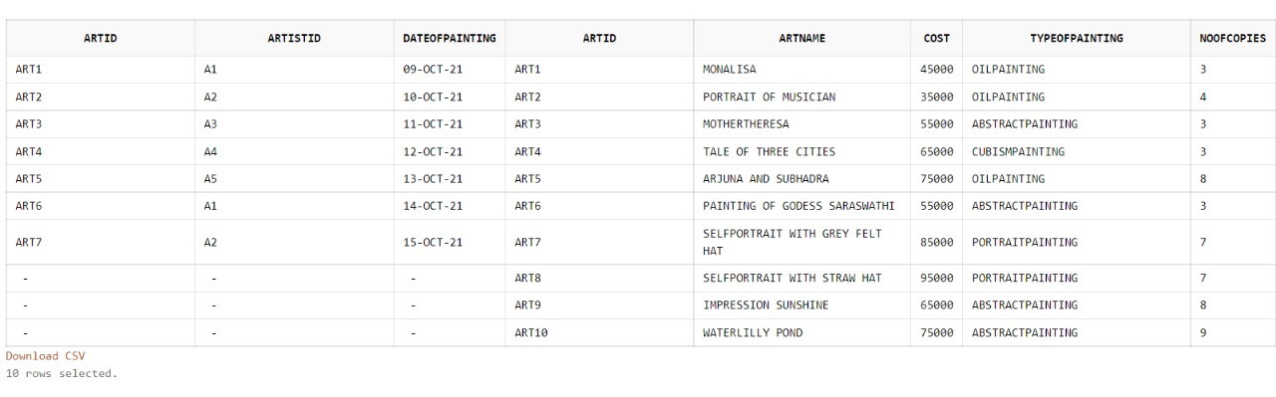

9. SELECT VISITOR NAME, VISITOR ID WHO VISITS THE EXHIBITION EITHER THE VISITORS OR VIPS, ORDER ACCORDING TO THEIR VISITOR NAME

QUERY:

SELECT VISITORNAME,VISITORID FROM NORMALVISITOR UNION SELECT VISITORNAME,VISITORID FROM VIP ORDER BY VISITORNAME;

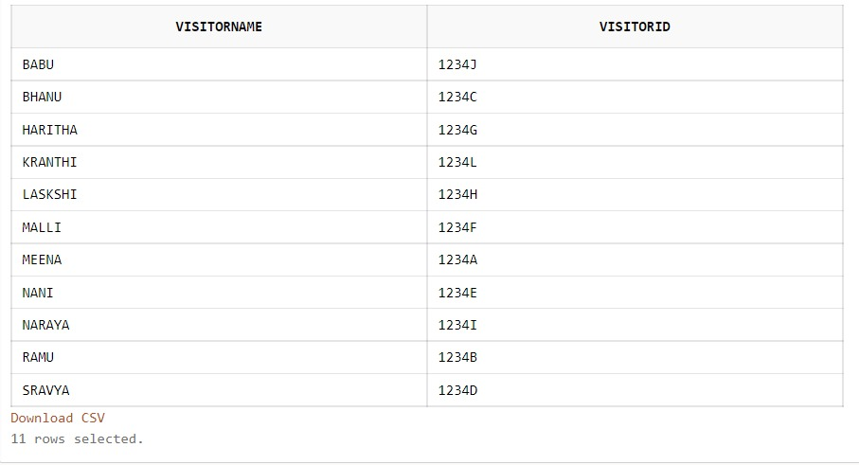

10. BILL ID WHO BUY PAINTING EITHER MONALISA OR PORTRAIT OF MUSICIAN ?

QUERY :  
SELECT BILLID FROM ORDERS O WHERE O.BILLID IN (SELECT B.BILLID FROM BILL B WHERE B.ARTID IN((SELECT A.ARTID FROM ARTGALLERY A WHERE A.ARTNAME='MONALISA') UNION (SELECT A.ARTID FROM ARTGALLERY A WHERE A.ARTNAME='PORTRAIT OF MUSICIAN')));

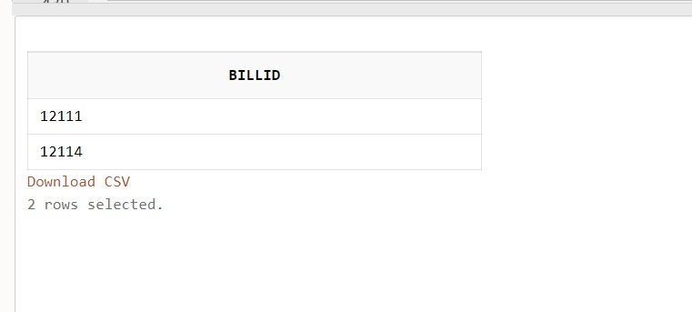11. QUERY ON BILL ORDERS ARRANGED IN DATE OF PURCHASE ?

Query :

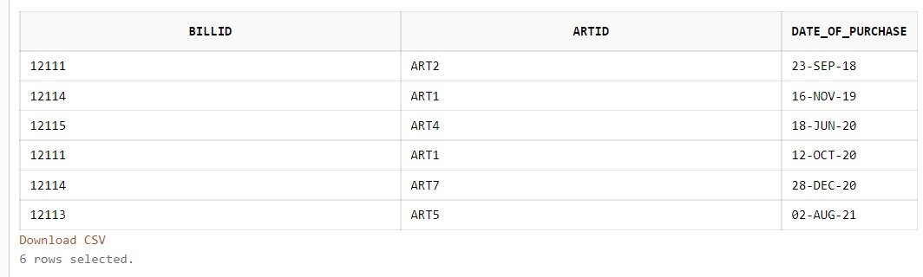SELECT * FROM BILL ORDER BY DATE_OF_PURCHASE;

12. EXIHIBITION DETAIL ON WHO ATTENDED IN BETWEEN DATES 29-OCT TO 9-DEC ?

QUERY:

SELECT EXHIBITIONID,EXHIBITIONNAME,STARTTIME,ENDTIME FROM EXHIBITION WHERE DATEID BETWEEN '29-OCT-2021'AND '9-DEC-2021';

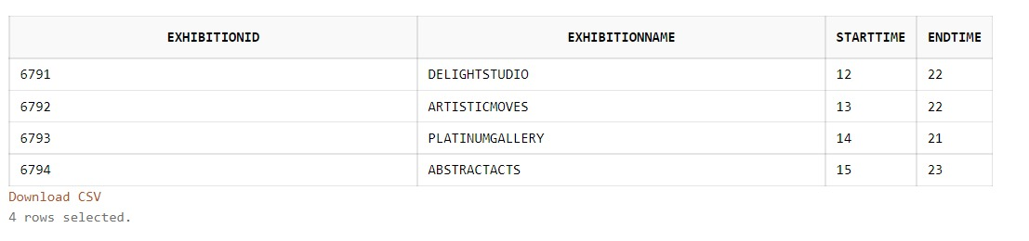

13. SELECT ARTID ARTISTNAME ADDRESS WHO PAINTS THE PAINTING ?

Query:

SELECT ARTID,ARTISTNAME, ADDRESS FROM ARTIST, PAINTS WHERE PAINTS.ARTISTID = ARTIST.ARTISTID;

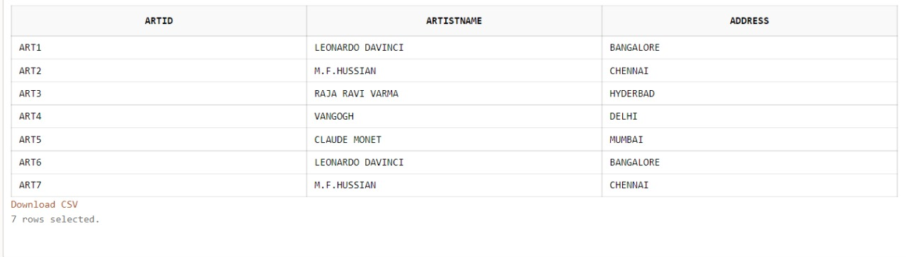

14. QUERY FOR COUNTING TYPE OF PAINTINGS IN ARTGALLERY?

QUERY:

SELECT COUNT (TYPEOFPAINTING) AS TotalPAINTINGS FROM ARTGALLERY ;

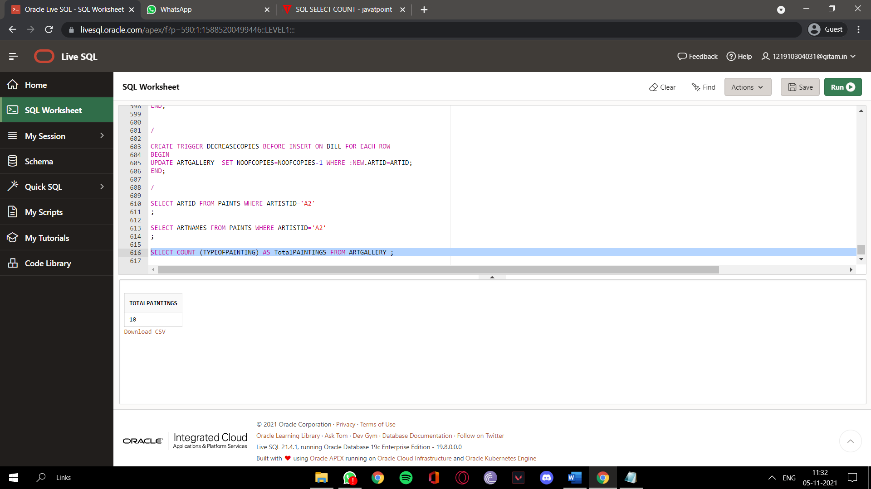

15.SELECT THE TYPE OF PAINTINGS WHERE ARE THE NUMBER OF COPIES GREATER THAN 2

QUERY:

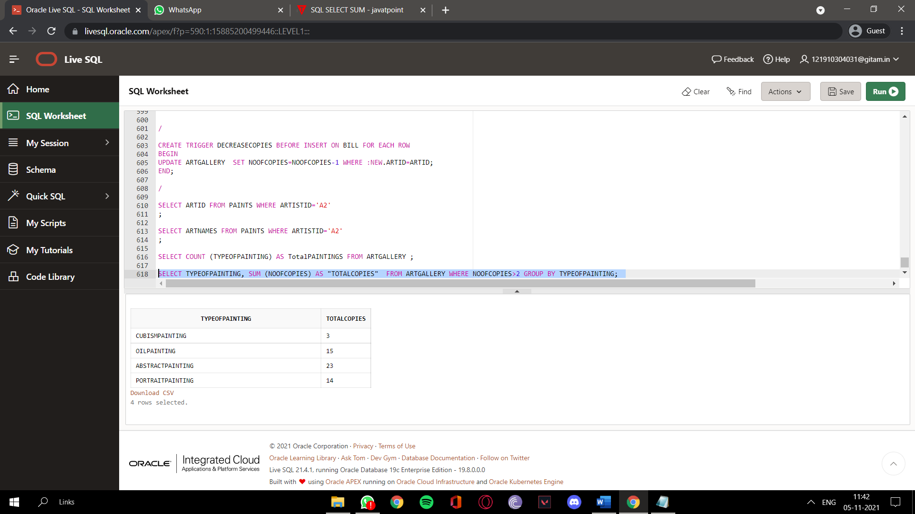SELECT TYPEOFPAINTING, SUM (NOOFCOPIES) AS "TOTALCOPIES" FROM ARTGALLERY WHERE NOOFCOPIES>2 GROUP